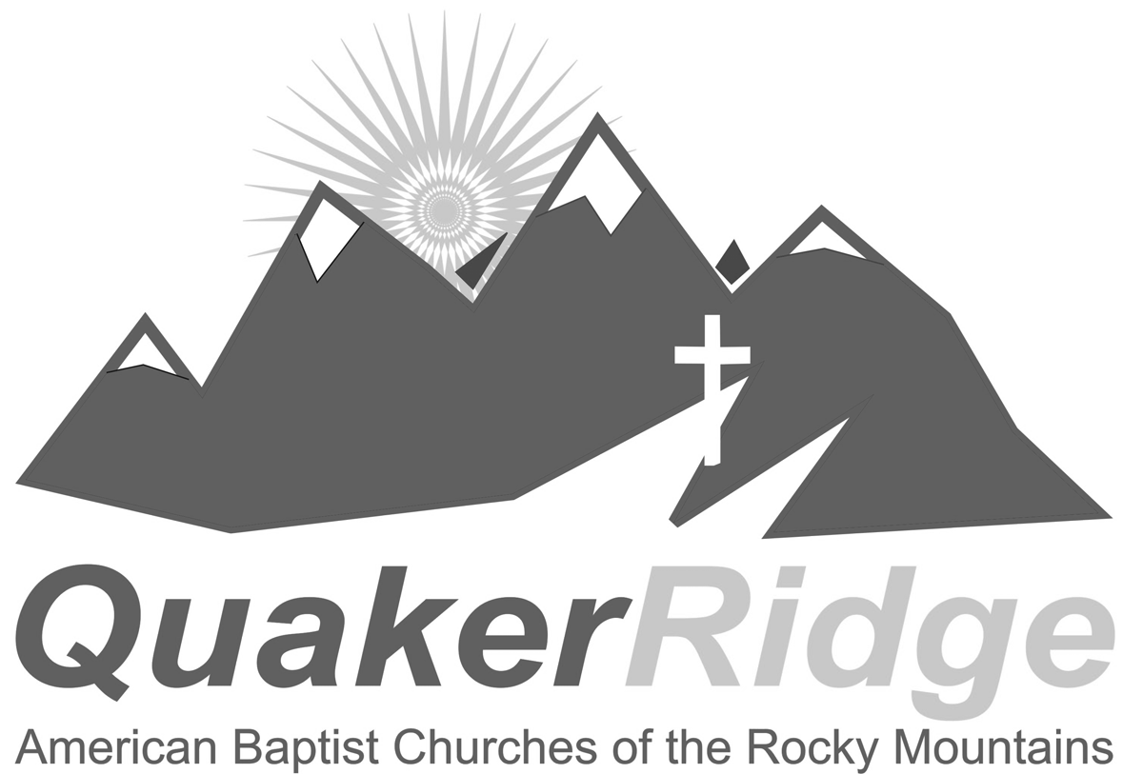
Front Range Camping
July 13-19, 2014

American Baptist Churches
of the Rocky Mountains
Camping at Quaker Ridge Camp

Information for Parents

CAMP OPENING/CLOSING
Registration will be from 3:00 p.m. to 5:00 p.m. on Sunday, July 13. Camp ends on Saturday, July 19. Campers can be picked up beginning at 10:00 a.m. on Saturday. All campers must be picked up by 11:00 a.m.

NEW!! CANCELLATION/REFUND POLICY. Cancellations received by June 15, 2014 will receive a 90% refund. Cancellations received by June 30, 2014 will receive a 75% refund. Cancellations received July 1-11, 2014 will receive a 50% refund.

MAILING ADDRESS DURING CAMP
Your child’s name, c/o Quaker Ridge Camp, 30150 N. Hwy 67, Woodland Park, CO 80863

TELEPHONE
For emergencies, contact Sylvia Hale at (719) 360-5454 or Bill Hale at (719) 271-0486

SUPERVISION AND PARTICIPATION
Campers are under the supervision of a cabin leader and the camp program director(s). Campers are expected to abide by the rules of Quaker Ridge Camp and the American Baptist Churches of the Rocky Mountains (ABCRM) at all times and are expected to participate in all camp activities unless specifically excused by a doctor or the parent in writing. The ultimate result of non-participation and/or consistent problem behavior may be the expulsion of the camper from camp and return to home.

INSURANCE
There is a place on the Health and Examination Form to indicate the name of your insurance carrier and the identification number(s) for camp personnel to use if it is necessary to take your child for emergency medical care. Please fill that information out completely.

MONEY NEEDED
In addition to the camp fee, money may also be brought for the Snack Shack and the purchase of souvenirs. Small denominations please – nothing over $10.00 bills.

WHAT TO BRING
- Camper’s clothing needs to be modest. For girls, this includes a minimum inseam on shorts of at least three inches, midriffs covered, and shoulder straps at least two finger widths. Boys pants will be expected to cover the top boxers/underwear (i.e. no droops).
- Sleeping bag, pillow and/or blankets and sheets for assigned bed. Quaker Ridge does not supply any bedding! Elementary and Middle School campers have twin beds; Sr. High campers have queen size beds.
- Towel, soap, shampoo, toothpaste, toothbrush, bag for dirty clothes, plastic bag for wet clothes, etc.
- Water bottle, flashlight, extra batteries
- Sunscreen and sunglasses
- Bible, notebook, pens/pencils
- Appropriate swimsuit (1 piece only for girls) and towel
(over)
- Long pants and closed toe shoes for riding horses – no sandals, flip-flops, or slippers
- Sweatshirt, fleece hoodie and long pants for campfire time at night
- A cap, extra towel and extra pair of shoes are recommended
- At least 6 changes of clothing
- Rain poncho
- Money for Snack Shack – soft drinks, t-shirts, candy, ice-cream, popcorn, etc.
- Prescription and over-the-counter medications. All medications must be in their original packaging with instructions. All medications will be turned over to the camp nurse.
- Campers with long hair should bring hair ties that securely hold hair back to keep it out of ropes and carabineers.

WHAT NOT TO BRING
- Loop earrings (and other facial rings) should not be worn because of the potential of serious injury during many camp activities.
- No electronic entertainment devices

- iPods
- Gameboys
- Radios
- CD Players
- MP3 Players
- Stereo
- DVD Players

CAMP RULES
- No pets
- No tobacco
- No alcohol or drugs
- No fireworks
- No matches
- No temporary or permanent tattoos will be applied while at camp
- No weapons (guns, knives, etc.)
- No profanity
- No fighting
- No open-toed sandals (flip-flops for the shower and going to the pool are okay)
- No P.D.A. (public displays of affection)
- No littering, vandalism, or graffiti
- No 4-wheelers, dirt bikes, or off road motor vehicles
- Leave the wildlife alone
- 15 mph speed limit in camp
- Do not climb on roofs, trees, or buildings
- Cell Phone with limited use is allowed (at camp directors/counselors discretion)
- Guys in guys cabin only, girls in girls cabin only

